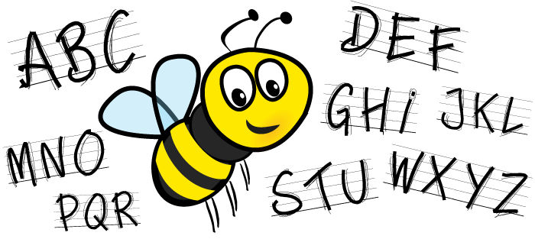
P5 Spellings & Phonics
Week Beginning 7th September 2020

Group 1

Phonics | Topic Words | Synonyms
double letters (ff, ll, ss, zz, tt) | Kings & Queens | ‘get’
waffle  toffee  hallway  pulling  dressed  crossed  grizzly  buzzard  butterfly  mutter | king  queen  castle  Henry  Tudor | earn  gain  catch  develop  acquire

Group 2

Phonics | Topic Words | Synonyms
double letters (ff, ll, ss, zz, tt) | Kings & Queens | ‘get’
effort  muffin  called  telling  messy  pressed  fizzy  puzzle  butter  bottom | king  queen  castle  Henry  Tudor | earn  gain  catch

Group 3

Phonics | Topic Words
double letters (ff, ll, ss, zz, tt) | Kings & Queens
bluff  offer  coffin  traffic  thrill  drill  bossy  stress  jazz  whizz | king  queen  Tudor

