P5 Mental Maths

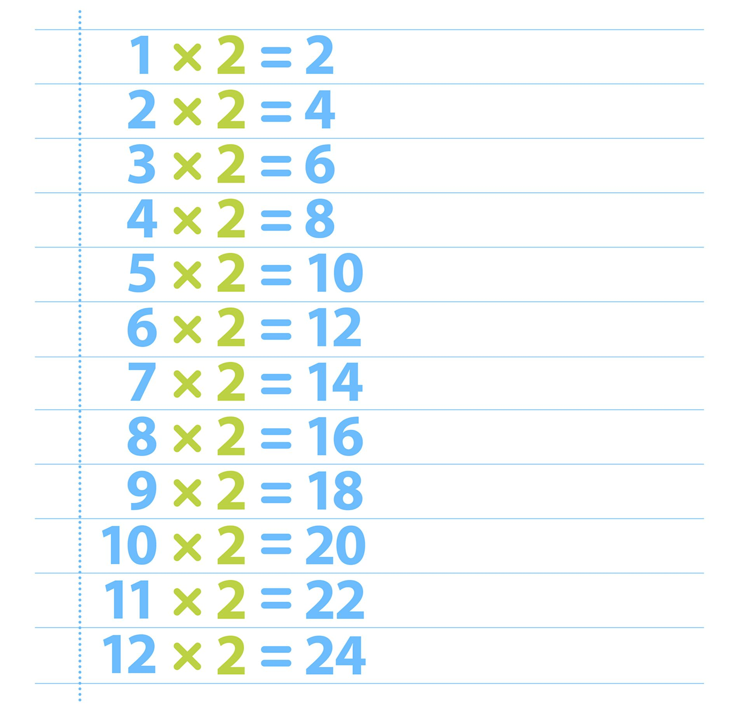
Week Beginning 7th September

