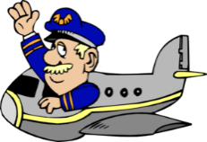

**Captain Andrews’**

**FLIGHT experience**

**Lesson 5: Drag**

**Trainee Pilot:_________________**

**What is drag?** Drag is a form of f____________ known as a_____ r______________.

Drag is the force that opposes an aircraft’s motion through the air.

Drag acts in the opposite direction to the motion of the aircraft caused by THRUST.

On the diagram below, mark on the forces acting on the skydiver

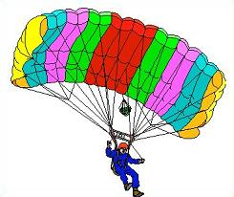

You are now going to complete the ‘gyrocopter’ challenge.

You are going to test each of the three sizes of gyrocopter three times. You will drop the gyrocopters from the highest accessible point that you can and time how long each gyrocopter takes to reach the ground. Record your method, results and conclusion using the resource sheet.

What could be done to reduce drag, and why would this be of advantage to an aeroplane?

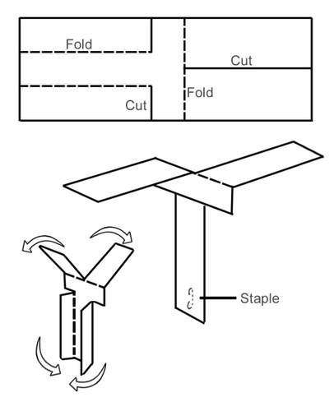

A few staples or a paperclip here will add weight and help the gyrocopter to fall.

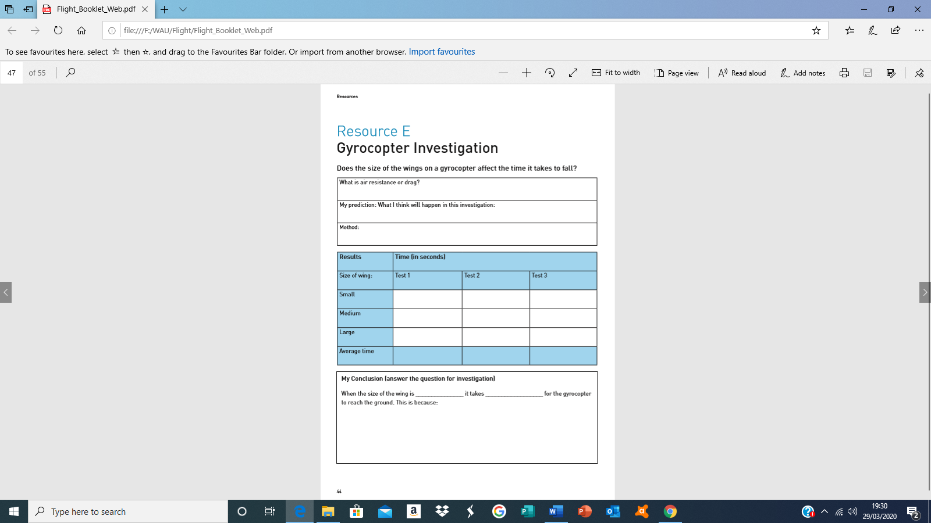Think DRAG and what it will do to the speed of a falling object.