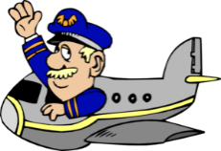

**Captain Andrews’**

**FLIGHT experience**

**Lesson 4: Thrust**

**Trainee Pilot:_________________**

A vitamin tablet contains a substance called SODIUM BICARBONATE. When water is added to it, it releases a gas called _ _ _ _ _ _ _ _ _ _ _ _ _*. This is what makes the water fizz!

Making a lid go ….

What we did:

What happened and ***WHY!***

* An anagram of this answer is ***android icebox.*** It’s also the gas you mostly exhale!