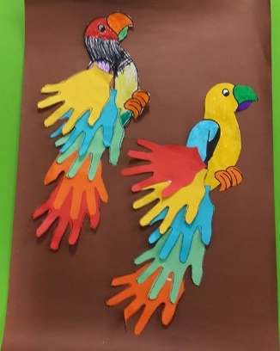Use the template of the parrot below. Draw around you hand on lots of pieces of paper. Cut them out and make a handprint tail for the parrot. Can you make a colourful tail like this one?

