Numeracy guidance week beginning 18th May 2020

This week we would like to introduce addition. To do this with children this age we would talk about from the perspective of ‘combining sets’. For the children we would say ‘How many will I have if I put these sets together?’ We would not yet use the + and = symbols. At this stage when discussing this learning we would use the language ‘1 and 2 is the same as 3’, ‘2 and 2 is 4’ or ‘2 and 2 altogether makes 4.’ This continues on from our part part whole model.
At this stage this really needs to be taught practically. There are some ideas below:
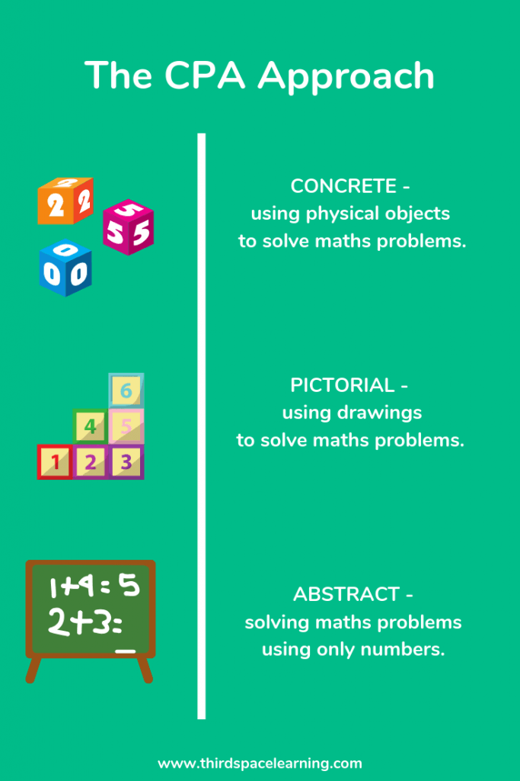
Over the next couple of weeks we can introduce the + and = symbols.

We would first write:

2 and 1 altogether makes 3.

We would then say to the children that instead of using ‘all those letters’ (and) we can just use this symbol + and
instead of having to write ‘is the same as…’ we can just put this symbol =

We can then discuss how there are lots of ways we can say ‘and’ – plus, add,etc but we just use +
Also then discuss that there are many ways to say = ; is the same as, equals, altogether.

The language and discussion of all mathematical concepts is very important. We can easily jump to showing
children the symbols and tell them what they mean. The children will often appear to pick it up quickly,
but we have to be sure they understand it. It’s imperative that they are completely secure in the
concept, of what they are doing and why they are doing it. As the children move up through the school mathematical concepts begin to come thick and fast and if the foundation of the knowledge is not there the children can struggle later. ‘Overlearning’ is useful in maths.

(We hope this comes across as passionate rather than overzealous!)

