

**Neon – Haiku**

Neon – inert gas

When heated, glows vivid red

For dazzling adverts.

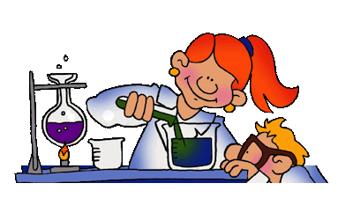

Coloured light adds so much to our enjoyment of the environment around us. Just try to imagine a world without colour! No beautiful clear blue skies, no yellow sunflowers or red roses, pink candyfloss or green grass. Boring? You bet!

The colours that we see are all produced from different mixtures of just seven colours. Do you know what they are?

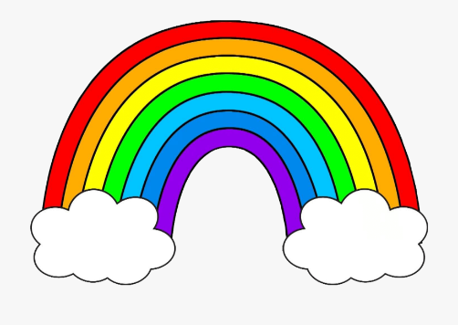**R O Y G B I V**

The rainbow or **spectrum** is formed when what we call white light is split into its constituent parts.

Just to prove it, you can conduct an experiment to split light into a seven-coloured spectrum. Here’s how!

**You will need:**

* A small mirror – hand sized or a little bigger
* A battery-operated torch
* A basin
* Water

**What to do:**

1. First of all, make sure that you are working in a darkened room.
2. Half fill the basin with water.
3. 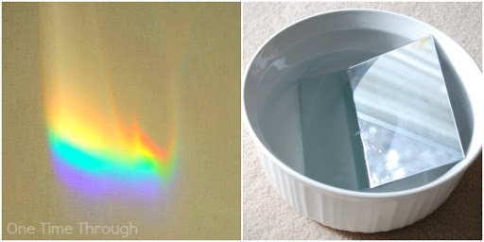Angle the mirror against the edge of the basin so that somewhere between a third and a half of it is submerged.



1. Now shine the torch through the water and onto the mirror.
2. Manoeuvre the beam of the torch until you see a spectrum produced onto the ceiling or wall. You can even try to ‘catch’ the spectrum onto a piece of white paper, but you may need some help from another person to hold the paper!

**What’s going on?**

When light passes through water it is bent. But remember that ‘white’ light is actually made up of the seven colours of the spectrum, so these all bend too when the light passes into the water.

The key thing is, however, that each colour bends a little bit differently than the others. In this way, the white light splits into the spectrum.

The mirror does what a mirror does and reflects the spectrum up and out of the basin.

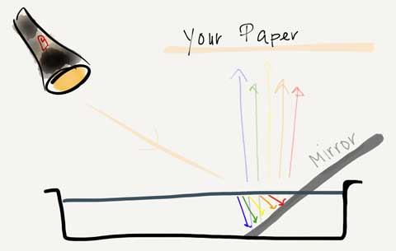



Neon was first discovered way back in 1898. It is one of a group of gases that hardly react with anything else. Boring huh? Neon should be the most boring of all as it reacts with **absolutely nothing**!

However, a Frenchman called Georges Claude decided to put neon inside a sealed glass tube and fire electricity through it. Well, why wouldn’t you?

Anyway, when he did this the tube glowed a brilliant red colour. Beautiful it may have been, but not very practical for lighting your living room.

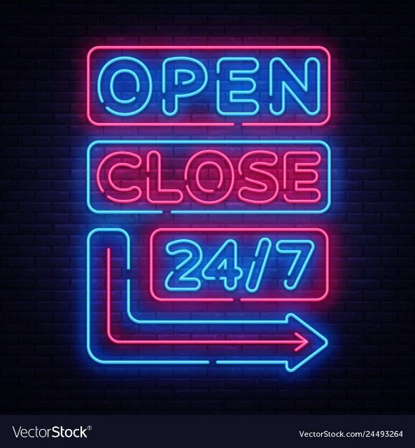After a mere 10 years of thinking about what to do with his new neon light, Georges discovered that if he bent the glass tubes into the shapes of letters, he could create rather fantastic signs. A whole new way of advertising had been invented.

Neon will only glow red. The colours of other ‘neon lights’ are caused by other gases.

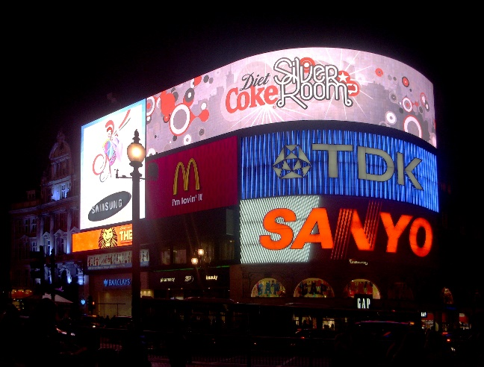Why not try to design your own neon sign? Use only lines rather than blocks of colour. Use different colours. Will you make it static or flashing? What product will you advertise?

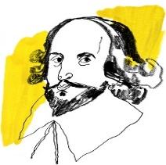

A Haiku is a traditional Japanese poem. It follows a very strict pattern consisting of 17 unrhymed syllables organised in 3 lines.

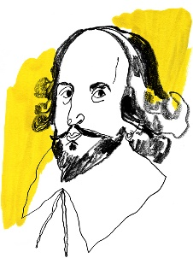

**Line 1 – 5 syllables**

**Line 2 – 7 syllables**

**Line 3 – 5 syllables**

A **syllable,** by the way, is a part of a word that contains sounds (phonemes) of a word. It usually has a vowel in it. For example spi- der- Spider has 2 syllables.

Why not have a go at writing your own haiku? If it helps, there is a simple pattern that may help:

Where it happens

What is happening

When it occurs

So, for example:

On my backyard fence

A cat sings his lonely song

Each hot summer night.

**It’s really important that the thought should come first. You can adjust the count of syllables as you go along.**

In freezing weather

Little snowflakes start

Catch them on your tongue.