Missing words

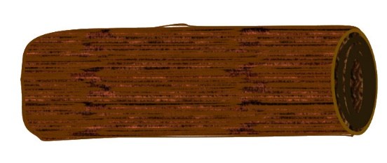

[This Photo](https://www.flickr.com/photos/bycp/5663797165/) by Unknown Author is licensed under [CC BY-NC](https://creativecommons.org/licenses/by-nc/3.0/)

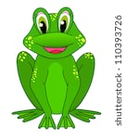I can on a log.

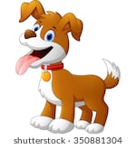A can swim.

We can see a .

dog frog sit