Literacy – 27th April 2020

Phonics:

Recap over all sounds learnt so far:

s, a, t, p, i, n, c, k, ck, e, h, r, m, d, g, o, u, l, f, b.

Learn new sound ‘j’. Talk about the name and then the sound.

Activities: Can you make a word web of words that begin with j ? e.g:

jump
jam

J j
jelly
jar
jigsaw

Alphablocks link:

https://www.youtubekids.com/watch?v=LPJi_ZzyRdA&hl=en-GB

We have tried to use Youtube Kids whenever possible. Athough some of our links are just to You Tube. If you have not previously opened Youtube Kids, it will ask you to specify the age of the child. There is also the option to ‘narrow’ the search facility your child will have.

Here are some other useful links for ‘j’.

https://www.youtubekids.com/watch?v=6KXX6fCKWes&hl=en-GB

Jolly phonics song:

https://www.youtube.com/watch?v=-b9asCO1Uxk

There are worksheets on the Primary 1 page to practise the formation of letter ‘j’. These are available to download and print.

Use these ideas to introduce the letter ‘z’.
Make a word web of words that begin with ‘z’.

Alphablocks clip:

https://www.youtubekids.com/watch?v=jjQlGffaaP8&hl=en-GB

Z song

https://www.youtubekids.com/watch?v=-TV4QpjgCE4&hl=en-GB

Jolly Phonics ‘z’ rhyme:

https://vimeo.com/106231366

This clip is the jolly phonics songs for all the letters of the alphabet. Letter ‘z’ is at 7 mins 38.
The first half of the clip will be useful for all the letters too though! Don’t worry about the second half of the clip though!

Letter formation sheets on the website.

Reading:

Oxford Owl website:

Read Cats: There are reading activities to complete afterwards.
(You will need to log in to Oxford Owl. The website is free but you need to register.)

https://www.oxfordowl.co.uk/home/reading-site/find-a-book/library-page?type=book&view=&query=Cats

Read Tiger’s family:

https://www.oxfordowl.co.uk/home/reading-site/find-a-book/library-page?type=book&view=image&query=Tiger%27s+family

There are some activities to complement the books.

Share stories at home:

Read through some stories with an older brother / sister or parent. You can play this game afterwards.
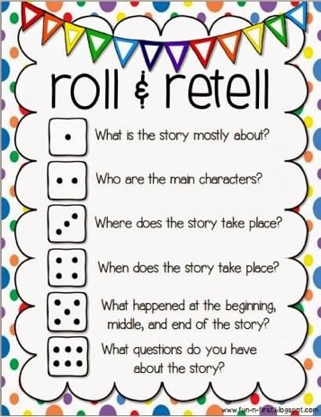

Writing:

Practice your high frequency words on a whiteboard, with water and a paintbrush or just on paper.

Try and sound out some words yourself or write a sentence. e.g: car, bus, sun or some phrases like: I miss school. or I like to play. Don’t forget to use a capital letter and a full stop.
Look at our Spring PowerPoint. There are some opportunities for drawing and writing in it.

Please remember that this is guidance. It gives you an idea of how we would teach this in school. Please complete these activities in your own time and do not feel under any pressure. We realise this is not the easiest time for anyone.

Sending our thoughts and best wishes

Mrs B and Mrs K xx

